Nema 23 Mounting Bracket Dimensions

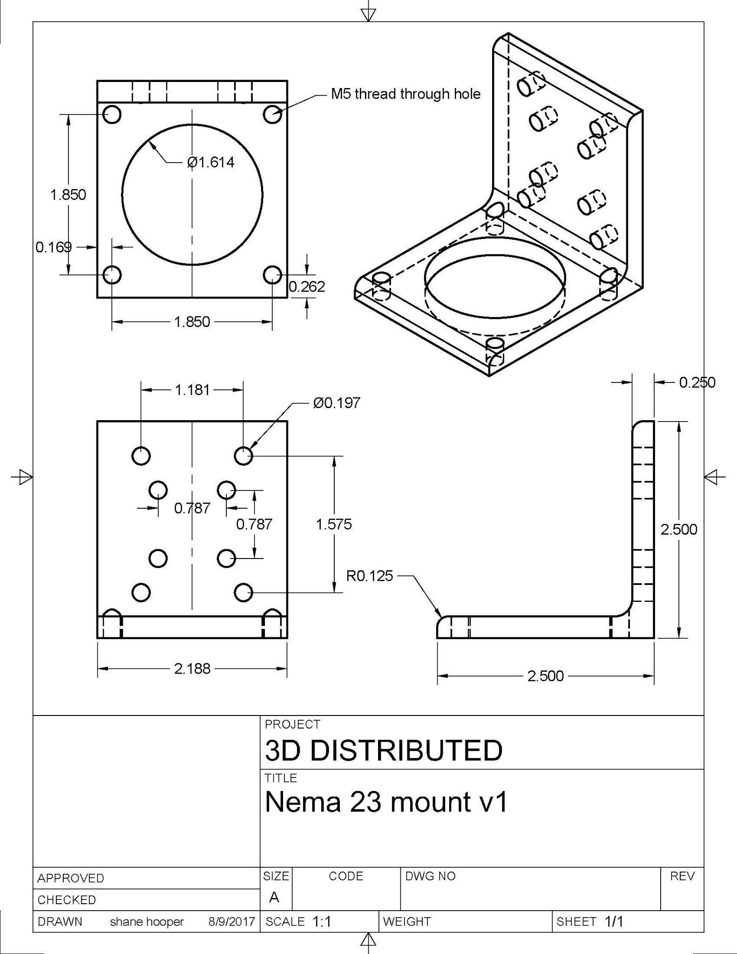
Nema 23 Motor Mounting Bracket

Nema 23 Mounting Bracket Dimensions

Related Content
Nema Motor Mounts
nema 23 mounting bracket dimensions

Related Content
WorkHorse BOM
Igus Lead Screw
Linear Rails
WorkHorse Frame
WorkHorse Motors
WorkHorse Printer: Users Guide
Duet Wifi Setup
Duet 2 vs Duet 3
WorkHorse 3D Printer
Recommended Print Settings
3D Distributed

Firmware Files
config.g
Homeall.g
homex.g
Homey.g
Homez.g

Duet 3 Mainboard Setup
Duet3D YAT Commands
Reverse Motor Direction

Duet Wifi
Duet Wifi Setup

